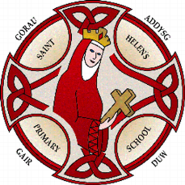
St Helen’s Primary School
Ysgol Helen Sant
Health and Wellbeing Policy
2022:

Our mission is to
"Strive to achieve; Take care of our world; Look after each other"

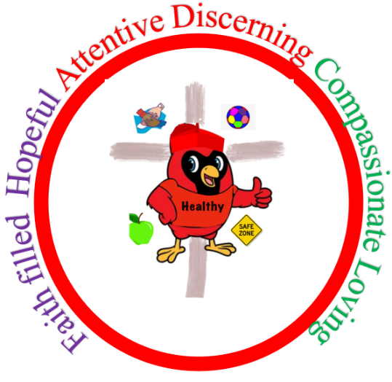

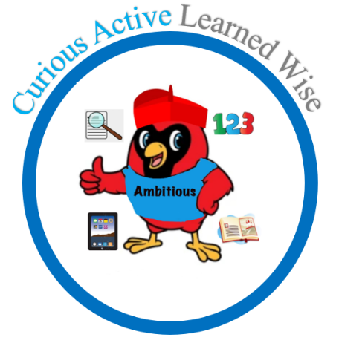
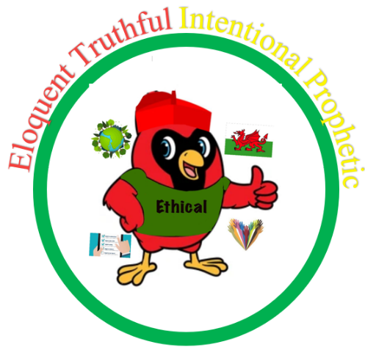

Approved by.......................................S.Sanchez................................... Headteacher

Approved by......................................Rob Thomas............................. Chair of Governors

Approved by........................Laura Jeffereis......................Health and wellbeing Lead

Approved by..............................Amy Jenner............................... Lead Governor

Approved by.......................Gethin O’Shea............ First Minister of pupil Senedd

Approved by.....................Carys Jones................... Deputy Minister of pupil Senedd
We put the United Nations Convention on the Rights of the Child (UNCRC) underpins our school vision and aims, in particular through Pupil Voice we encourage children to:
• listen to others and respect their ideas
• learn our rights, respect the rights of others and to inform others of children’s rights

1 Health and Wellbeing is holistic
1.1 In St. Helens the Health and Well-being Area of Learning and Experience provides a holistic structure for understanding health and well-being. It is concerned with developing the capacity of learners to navigate life's opportunities and challenges.

1.2 The fundamental components of this Area are physical health and development, mental health, and emotional and social well-being. It will support learners to understand and appreciate how the different components of health and well-being are interconnected, and it recognises that good health and well-being are important to enable successful learning.

1.3 Links to Children's Rights: Learning within the Health and Well-being area of learning supports children to understand their rights and the rights of others (Articles 2 and 42 of UNCRC). It also supports children to experience their rights to be safe and protected from harm (Articles 19, 33, 34, 36) and also promotes the right of children to relax and play (Article 31) and to have healthy food and clean water (Article 24)

2 What Matters in Health & Well-being
2.1 In St Helen’s we will plan, track and develop experience, skills and knowledge across progression steps for the following :
- Developing physical health and well-being has lifelong benefits.
- How we process and respond to our experiences affects our mental health and emotional well-being.
- Our decision-making impacts on the quality of our lives and the lives of others.
- How we engage with social influences shapes who we are and affects our health and well-being.
- Healthy relationships are fundamental to our well-being.

2.2Progression in Health and Well-Being
Progression Step 1,2 and 3 will collaborate to ensure coverage of skills and ensure children progress at their own stage. We stive to develop a curriculum that will do the following for pupils:
- Increase breadth and depth of knowledge
- Deepen understanding of the ideas and disciplines within the area of learning and experience
- Refine and grow sophistication in the use and application of skills
- Make connections and transfer learning into new contexts
- Increase effectiveness as a learner

2.3The What Matters statements are parted into the following:

Developing physical health and wellbeing has life long benefits
In St. Helen’s we teach and develop physical health through:-
- Food and fitness policy
- Daily activity through play
- Snack fruit or vegetables
- Healthy Lunch Boxed
- Water Fountains and bottles
- Extra curricular Sports clubs
- PE and Games lessons for skill development
- Competitions
- Sports Day
- Science of health lessons
- Healthy Cooking and Eating Activities
- Healthy Schools
(See food and fitness policy)

How we process and respond to our experiences affects our mental health and emotional wellbeing
In St. Helen’s we teach and develop mental health through:-
- Self regulation areas and resources
- Flexible timetables to meet pupils’ needs
- Effective links with outside agencies
- Well-being Awareness Days
- Self Regulation Charts and Strategies
- Calm areas
- Thrive room
- Buddy stop on yard
- Daily or Routinely Check ins
- Circle Time
- Promote resilience
- Growth Mindset
- Restorative Practice - A consistent approach to developing positive relationships (See relationship policy)
- Flexible use of time to meet pupils' needs
- Wellbeing sessions for those children with Targeted and Specialist needs
- Thrive/ ElSa
- Relationships and Sexuality Education through Life to the Full
- A consistent approach to the emotional environment
- Value placed on opportunities for dependence/ independence and interdependence
- Strong pupil voice opportunities for all pupils in class and Senedd
- Authentic Contexts for Learning
- Encourage pupils to talk through their understanding of learning and actions and emotions
- Make changes to the environment to suit the needs of the learners when necessary eg routines, displays, groupings, resources, self-regulation tool
- Create an emotional environment which actively supports pupils to talk about their feelings and needs
- Whole school approach to support children through universal, targeted and specialist provision.
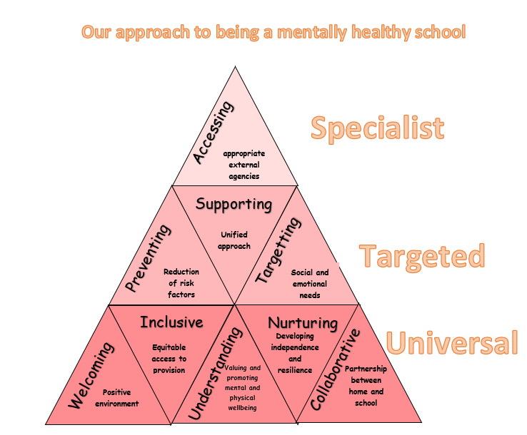

Our decision making impacts on the quality of our lives and the lives of others
In St. Helen’s we teach and develop decision making through:-
- Assess risks during Forest School and Science Investigations
- Group work in lessons coming to a decision
- Senedd decisions - impact on future learning
- Identifying risks to health -food, hygiene and fitness
- Visits from Police, Health Nurse
- Engagement with Life to Full Relationships and Sex Education (See RSE policy)

How we engage with social influences shapes who we are and affects of health and well being
In St. Helen’s we teach and develop this through:-
- Follow rules of class and playground, during field trips
- Learn about other faiths and cultures
Healthy relationships are fundamental to our well being
In St. Helen’s we teach and develop healthy relationships through:-
- Engagement with Life to Full Relationships and Sex Education (See RSE policy)
- Relationships policy
- Restorative approaches
- Conflict resolution using Peer mediators
- Rights of the month
- Circle time and Assemblies on Childrens Rights
3 Rights
3.1 Children and young people have 42 rights under the United Nations Convention on the Rights of the Child (UNCRC). These 42 rights give children and young people what they need to grow up happily, healthily and safely. In 2011 Wales became the first country in the UK to make the UNCRC part of its domestic law.
3.2 The principles of a Children’s Rights Approach are:
- Embedding children’s rights - at St Helen’s this means that all policies are underpinned by the UNCRC, and all our community know and understand about children's rights.
- Equality and Non-discrimination - at St Helen’s we make sure that every child aspires to be the best they can be. This is encapsulated in our school Vision and Mission statements
- Empowering children - At St Helen’s pupils are actively involved in planning their curriculum.
- Participation - At St Helen’s adults and pupils share the decision making and together drive policy and change.
- Accountability - St Helen’s Primary School is held to account for how pupils experience their rights by the governing body and pupil voice groups.

4 Positive Relationships
4.1 The response to misbehaviour is always positive and will depend on the nature of the misdemeanour, and the age and maturity of the pupil. We deal with any misbehaviour using a restorative practice approach. This enables the pupil to explain their thoughts and reasons for their behaviour choice through 3 questions.
1. What happened?
2. How were you feeling?
3. What could we do next time?
This enables pupils to be listened to and also makes them aware of the effect that their actions have on others.
4.2 We are currently working with WRAP who are helping us to create a restorative school with wellbeing and positive relationships at it’s core.
4.3 We encourage our learners to develop self-regulation, and to understand the “how and why” of their emotions in order for them to develop strategies to best help and support them.

5 Additional Learning Need
5.1 At St Helen’s Primary School we recognise that all pupils come to school at different stages of development and with different needs. Whilst many factors contribute to the range of difficulties experienced by some children, we believe that much can be done to overcome them by parents, teachers and pupils working together. Pupils who meet our criteria for having ALN will be supported by class teachers, teaching assistants other adults and their learning environment.
5.2 The health and wellbeing aims for the pupils with Additional Learning Needs of the school are:
- To meet the needs of all pupils through excellent teaching strategies of Health and wellbeing, classroom organisation and differentiation.
- To have a whole school Universal Provision that addresses the needs of all pupils.
- To ensure that all pupils have access to a broad and balanced curriculum
- To ensure that early identification of a pupil’s needs is made of fine or gross motor skills
- To ensure that ALN pupils take as full a part as possible in all school activities
- To ensure that parents are kept regularly informed of their child’s progress
- To work in partnership with parents, pupils and other agencies e.g. Educational Psychologist, Speech Therapists, Social Workers, School Nurse etc.

6 Relationships and Sex Education
6.1 Relationships and Sexuality Education (RSE) is now mandatory and is considered as part of the Health and Well-Being Area of learning, as well as being a cross cutting theme across all learning. Our RE lead and SLT have agreed to use the Life to the Full and Fertile Heart Scheme. (See RSE policy) Throughout our lessons we will be using the correct terminology for body parts ie. penis, testicles, breasts and vagina.
6.2 Relationships and Sexuality Education will be introduced to the pupils through: ·
- Circle time activities
- Life to the Full Lessons
- Fertile Heart Lessons
- Curriculum subjects, e.g. Science
- Informally as opportunities arise in the classroom.
7 Assessment
7.1 We use the national literacy, numeracy and digital competence framework to plan, track and assess gainst. The Health and wellbeing what matters statements are for curriculum coverage.
7.2 The Literacy and Numeracy Framework (LNF)
The Literacy and Numeracy Framework describes in detail the skills that we expect children to acquire and master. It has two components – literacy and numeracy.

7.3 Within literacy we expect children to become accomplished in:
• Oracy across the curriculum
• Reading across the curriculum
• Writing across the curriculum.

7.4 Within numeracy we expect children to become accomplished in:
• Developing numerical reasoning
• Using number skills
• Using measuring skills
• Using data skills.

7.5 The LNF focuses on the learners’ acquisition of and to complete tasks appropriate for their stage of development.Teachers will use this statutory document to plan and assess pupil’s Literacy and Numeracy skills and their ability to apply the skills and concepts they have learned. The assessment will be supported by the National Literacy and Numeracy tests sat by pupils annually.

7.6 The Digital Competence Framework (DCF)
The Framework encapsulates the skills that will help learners thrive in an increasingly digital world.
The Framework has 4 strands of equal importance, each with a number of elements. Teacher plan for, track and assess against these skills.
- Citizenship – which includes:
- Identity, image and reputation
- Health and well-being
- Digital rights, licensing and ownership
- Online behaviour and cyberbullying.
- Interacting and collaborating – which includes:
- Communication
- Collaboration
- Storing and sharing.
- Producing – which includes:
- Planning, sourcing and searching
- Creating
- Evaluating and improving.
- Data and computational thinking – which includes:
- Problem solving and modelling
- Data and information literacy.

7.7 National Literacy Numeracy and Digital Competence Framework (LNF and DCF)
Literacy, numeracy and digital skills are essential in order for young people to reach their potential. We believe they are the key to assessing and closing the gap for our children. The National Literacy and Numeracy Framework and Digital Competence Framework has been developed to help achieve the Welsh Government’s aim that the children of Wales are able to develop excellent literacy, numeracy and digital skills during their time at school. Expectations for literacy, numeracy and digital skills are given for each school year group.
At St. Helen’s the LNF and DCF is at the heart of the curriculum planning, ensuring the embedding of literacy, numeracy and digital skills across the curriculum. This is reflected in the pupils learning where differentiated skills are set in the form of a MUST- below expected level, Should – on expected level, Could – above the expected level.
We use a planning, monitoring and assessment tool to support learning and teaching. We ensure that Literacy, Numeracy and Digital skills are embedded in lessons and enrichment tasks that are meaningful to the children’s learning experiences ensuring that skills are used in context leading to deep level learning and understanding.
(See Assessment Policy).

8 Parent and wider community involvement
8.1 We believe that children learn when learning and teaching is relevant to their lives in the wider community. In our school you will see:
- members of the local and wider community engaging in school life
- engagement with parents
- celebrations of national and international events and competitions
- programmes of extra-curricular activities
- visits to places which enhance pupils learning
- links with the local business community, charities and cultural organisations
- outdoor/ environmental focus
- team building activities
- Parent consultations are important in maintaining regular dialogue with parents. Opportunities are given to meet the teacher in the Autumn and Spring Term with an annual report being sent out at the end of the Summer Term when a further consultation may be organised if requested.
- Open door and phone call policy if there is a concern with a child at home

(See teaching and learning policy)

9 The role of Governors
9. 1 Our governors determine, support, monitor and review the school’s approach to teaching and learning. In particular, they:
• Support the use of appropriate teaching strategies by allocating resources effectively;
• Ensure that the school buildings and premises are used optimally to support teaching and learning;
• Check teaching methods in the light of health and safety regulations;
• Seek to ensure that our staff development and our performance management both promote good-quality teaching;
• Monitor the effectiveness of the school’s teaching and learning approaches through the school’s school’s development plan, self-review processes, which include reports from key phase/stage leaders, performance management of staff, the termly headteacher’s report to governors.
- Monitor My Concern and have a Lead Safeguarding Governor
(See teaching and learning policy and safe guarding policy)

10 Review
10. 1 We are aware of the need to review the Health and Wellbeing Policy regularly so that we can take account of new initiatives, changes in the curriculum, developments in technology or changes to the physical environment of the school. The policy will be reviewed at least every two years and more regularly if appropriate.
10. 2 This policy must be read in conjunction with the following policies:
- Assessment, Recording and Reporting Policy
- Curriculum Policy
- Teaching and Learning Policy
- Foundation Phase and Key Stage Two Policy
- Inclusion Policy
- ALN Policy
- EAL Policy
- Area of Learning Policies
- RSE policy

