St Helen’s Primary School
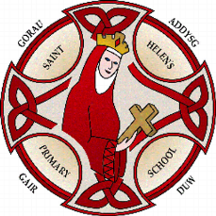
Ysgol Helen Sant
Food and Fitness Policy
2022:

Our mission is to
"Strive to achieve; Take care of our world; Look after each other"

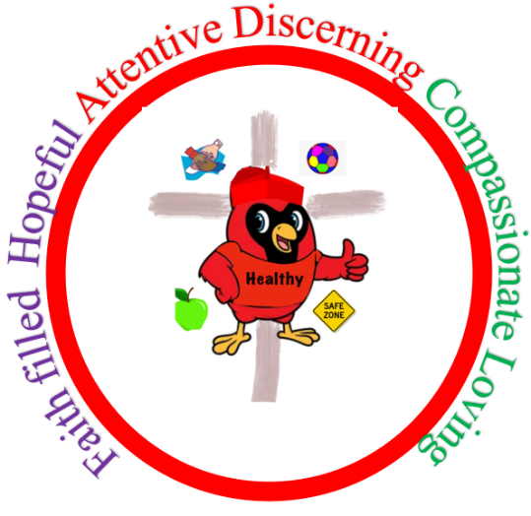

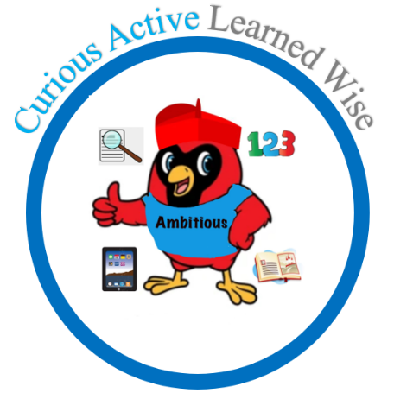

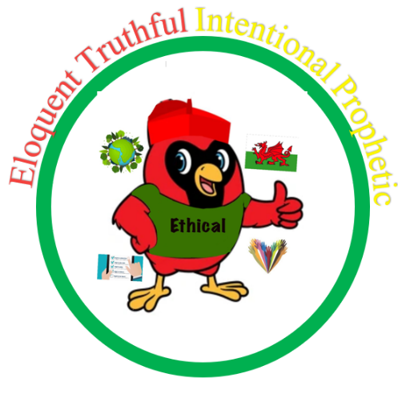

Approved by.......................................S.Sanchez................................... Headteacher

Approved by......................................Rob Thomas............................. Chair of Governors

Approved by........................Laura Jeffereis......................Health and wellbeing Lead

Approved by..............................Amy Jenner............................... Lead Governor

Approved by.......................Gethin O’Shea............ First Minister of pupil Senedd

Approved by.....................Carys Jones................... Deputy Minister of pupil Senedd

We put the United Nations Convention on the Rights of the Child (UNCRC) underpins our school vision and aims, in particular through Pupil Voice we encourage children to:
• listen to others and respect their ideas
• learn our rights, respect the rights of others and to inform others of children’s rights
Staff have matched the following articles from the UN Convention on the Rights of the Child to the Curriculum Policy: 1,2,3,4,6,12,13,15,23, 24, 27,28,29,30 and 31

1 Our School:
Our Mission : "Strive to achieve; Take care of our world; Look after each other"
  - Our Vision and values:
Our vision and values have been developed using the UN Convention on the Rights of the Child (UNCRC) as our guide, to create a safe and inspiring place to learn, where children are respected, their talents are nurtured and they are able to thrive. St. Helen’s Primary school has four values called Cardinals. These that are the foundation for our strategic purpose and aspirations for the future. We have used the four purposes from Curriculum for Wales, the Jesuit Pupil Profile virtues and the UN Convention on the Rights of the Child articles below to create our four values. We should form the basis of everything that we do in school should be primarily concerned with whether or not these purposes are being achieved.
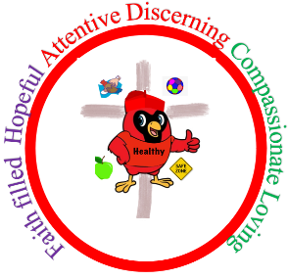
Healthy- Helping each individual in the school community to grow and to mature in the Catholic Faith and lead a fulfilling life as a valued member of society
The Purpose : Healthy, confident individuals ready to lead fulfilling lives as valued members of society
Article 24: Every child has the right to the best possible health.
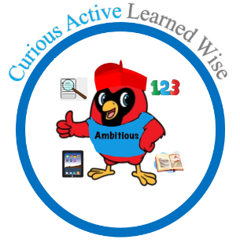
Ambitious- Ensuring that each child acquires the knowledge and skills to fulfill their potential and that each child develops moral sensitivity, independent thinking and initiative.
The purpose: Ambitious capable learners ready to learn throughout their lives
Article 28: Every Child has the right to an education
Enterprising - Helping children to solve problems and try new things to learn to play a full part in life and work
The purpose: Enterprising creative contributors ready to play a full part in life and work
Article 31: Every Child has the right to relax, play and take part in a wide range of cultural and artistic activities
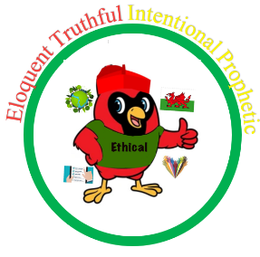
Ethical - Making an effective and creative contribution to the home - school- parish partnership and the rest of the world.
The Purpose : Ethical, informed citizens ready to be citizens of the world and Wales
Article 29: Education must develop every child’s personality, talents and abilities to the full & encourage respect for human rights, other cultures and religious beliefs, parents and the environment

Aims of the School’s Food and Fitness Policy
- To improve the health of the whole school community by equipping pupils with ways to establish and maintain life-long active lifestyles and healthy eating habits.
- To ensure that food and nutrition and physical activity become integral to the overall value system of the school and a common thread of best practice runs through the curriculum, the school environment and community links.
- To develop a whole school approach to food and fitness policy. A whole school policy offers a shared vision, coherence in planning and development, and consistency in the delivery of services, curriculum messages and the supporting environment. It facilitates discussion, encourages wide engagement of stakeholders and establishes belief and ownership in the aims and objectives it aspires to.
Objectives:
To promote pupil participation and decision making in all aspects of food and fitness activities.
To ensure that activities related to food and fitness provided for pupils throughout the day are consistent with curriculum guidance and Welsh Government regulations.
To work in partnership with School Meal Providers to ensure that consistent messages about nutritional standards and healthy lifestyles are given to our pupils.
To offer a broad range of safe, stimulating indoor and outdoor sports, play and recreational activities.

Implementation and Monitoring:
A named person is responsible for co-ordinating the policy at St Helen’s.
The governing body will take responsibility for the Food and Fitness policy.
The Senedd are actively involved with the implementation of the Food and Fitness policy.
The Senior Leadership Team will ensure that there is adequate training and resources for staff involved in the delivery of the aims and objectives of the school’s Food and Fitness Policy.
The Senior Leadership Team and governors will monitor progress at regular intervals.

Physical Activity within the Curriculum
- We are committed to providing 2 hours of timetabled, quality personalised physical activity per week for every pupil.
- Pupils will access physical activities in a person centered way. Pupils will have differentiated targets within a physical activity lessons to make sure that all pupils can progress their gross and fine motors.
- Primary pupils will engage in lots of physical learning.
- Progression Step 2 and 3 pupils have the opportunity to access learning in the community to promote community links and physical activities through sport competitions and swimming. This also allows pupils to become familiar and confident when using council leisure services.
- In line with the new curriculum (A curriculum for Wales, 2020) pupils will have the opportunities to make meaningful cross curricular links which are explored and developed.
- Opportunities of developing outdoor and adventurous education with a physical component are actively promoted.
- St Helen’s has developed alliances and partnerships with local providers such as; sports clubs, leisure centres and private sport/ gym facilities to allow pupils a range of different and inclusive physical activity opportunities.
- Pupils will be working towards the progression step descriptors within the What Matters Statement “Developing physical health and well-being has lifelong benefits” in the Health and Wellbeing section of the new curriculum (A curriculum for Wales, 2020).
- St Helen’s School have a range of safe, stimulating, clean, pupil friendly, inclusive and adaptable resources used to ensure all pupils can participate in physical activities.

Extra Curricular Physical Activity
- There is a range of extra curricula clubs appropriate to pupils across the entire age range. These are differentiated and completed after school.
- The Health and wellbeing Senedd will be receiving training to encourage physical activity during lunch times.
- Steps are taken to actively encourage physical activity during lunch/break-times. Specific equipment is made available to pupils to stimulate physical activity.
- The playgrounds will be set up to encourage physical activities and to stimulate and encourage all pupils to participate in activities during break and lunchtimes.
- Children who are above a healthy weight may be referred to social services. As a school we support the pupil and their family to have a better understanding of a healthy lifestyle.
- Pupils have allocated play times within the day.
- However some pupils who may have additional learning needs who may need more regular scheduled physical activities throughout the day. This will be delivered on an individual person centered approach.

Outdoor Education
- For primary pupils the primary yard is set up to be a stimulating and engaging environment and promotes physical activities with apparatus and equipment.
- Pupils have access to the forest school area during Forest School.
- As part of the curriculum, pupils are encouraged to actively participate in growing fruit and vegetables in the school grounds/ local allotments. Year 2 has access to the local allotment and the other classes grow produce in the schools allotment.
- The school promotes environmental and sustainable initiatives such as Eco Schools and Forest Schools.
- Pupils in Year 6 are allocated 1 weekend a year on a residential which delivers outdoor activities such as; orienteering, kayaking, gauge walking, caving, canoeing, mountain climbing, coastal walking, rock climbing, paddle-boarding and lake swimming.

School Travel Plan
- Due to most of our pupils having transport, not many of pupils walk or cycle to school. However, if pupils or staff decide to cycle we have an allocated space for the bikes to be safely stored throughout the day.
- Pupils are taught road safety from a very early age.
- Pupils are taught to hold hand s and to wait until the green man with an adult.
- Pupils are taught road safety when participating in regular community walks.

School Meals
- All school meals comply with Healthy Eating in Schools (Nutritional Standards & Requirements) (Wales) Regulations.
- Each menu works on a three-week cycle. This is to make sure there is variety and choice.
- St Helen’s will follow the statutory guidelines from the Welsh Government (https://gov.wales/sites/default/files/publications/2018-12/healthy-eating-in-maintained-schools-statutory-guidance-for-local-authorities-and-governing-bodies.pdf
- School Menus are communicated with parents.
- School Meals comply with Natasha’s Law. https://www.narf.org.uk/
- St Helen’s has developed welcoming aspects of the dining room environment including displays of food and promoting healthy eating.
- Free water is available for pupils.
- Healthy options are promoted which gives pupils the opportunity to try new foods.

Free School Meals
- Pupils who receive FSM are given healthy options which gives pupils the opportunity to try new foods.
- Reasonable steps are taken to protect the identity of pupils receiving FSM and the person / people responsible for FSM administration do not make unauthorised disclosures.

Food and Nutrition in the Curriculum
- Pupils will be working towards the progression step descriptors within the What Matters Statement “Developing physical health and well-being has lifelong benefits” in the Health and Wellbeing section of the new curriculum (A curriculum for Wales, 2020).
- Pupils will learn about food and nutrition through technology and cookery sessions. All pupils have access to have timetable for the Caffi.
- Cookery lessons teach pupils functional life skills.
- Pupils bring healthy snacks into school for break time and lunch times

Healthy Lunchboxes
- St Helen’s pupils and parents/ carers are encouraged to follow the Welsh Governments advice on healthy lunchboxes. (https://gov.wales/sites/default/files/publications/2019-02/healthy-lunchboxes-leaflet.pdf)
- Some of the pupils within St Helens have allergies to peanuts. Therefore St Helens have decided that any nut is banned to ensure our pupils are safe.
- Parents/ carers are encouraged to make their child’s lunchbox as healthy as possible.
- St Helen’s forbids fizzy or energy drinks to be consumed in school.
- Pupils are taught about the detrimental effects that energy drinks can have on people’s health.
- Children have access to water and are encouraged to drink this only.
- Children bring in water bottles to refill during the day.

Healthy Breakfast Club
- St.Helen’s has a Welsh Government Free Breakfast Club running in the school providing nutritionally balanced food.
- The breakfast provision also provides pupils with the opportunity of participating in a social situation encouraging pupils to communicate and develop table manners.
Milk
- All pupils in nursery, reception, year 1 and year 2 are provided with a carton of milk in line with the Welsh Government Guidance (https://gov.wales/sites/default/files/publications/2018-03/poster-for-schools-milk.pdf)

Drinking Water
- Pupils and staff have access to fresh, clean water at school throughout the school day
- The school provides water free of charge for pupils and staff in all 3 buildings.
- Children have access to water and are encouraged to drink this only.
- Children bring in water bottles to refill during the day.

Whole School Approach - Celebrations / Social Events / Rewards
- St Helen’s holds whole school events to promote healthy eating and physical activity (e.g. Sports week, Healthy Living week, walk to school week)
- The school promote non-food based birthday celebrations during assembly and in class.
- Fairtrade and Enterprise activities are either non-food based or try to promote consistent healthy eating messages.
- Fund-raising events and activities run by pupils and/or parents/carers/Friends of St Helens try to promote a consistent, balanced healthy eating message (i.e. not focused entirely on cake or sweet sales)

Oral Health
- St Helen’s School actively promotes oral health messages for example, tooth-brushing twice a day, limit sugary food, healthy snacks, fruit, milk and water at break times.
- The school will include oral health promotion in any parents meetings if there is a problem.

Monitoring and review

We are aware of the need to monitor the school’s teaching and learning policy, and to review it regularly, so that we can take account of new initiatives and research, changes in the curriculum, developments in technology or changes to the physical environment of the school. We will therefore review this policy every two years or earlier, if necessary.

In conclusion, the school environment is one where learning flourishes. Governing body members; staff, both teachers and support staff; adult volunteer helpers; parents and carers and pupils all learn from each other. It is a sustained sharing community where respect for each other’s opinions is relished as it becomes a learning community, each growing together towards a better future.

This policy must be read in conjunction with the following policies:
- Assessment, Recording and Reporting Policy
- Teaching and Learning Policy
- Foundation Phase and Key Stage Two Policy
- Inclusion Policy
- ALN Policy
- EAL Policy
- Food and fitness policy
- Wellbeing policy
- Area of Learning Policies

Useful resources

Appetite for Life – www.learning.wales.gov.uk
Dragon Sport - www.dragonsport.co.uk
Eating well at school – Caroline Walker Trust - www.cwt.org.uk
Eco-schools – www.eco-schools.org
Estyn Report on “School meals: Advice on the role of inspection in monitoring school meal standards.” - www.estyn.gov.uk/dynpages/publications_recent.asp
Food and Fitness – Promoting Healthy Eating and Physical Activity for Children and Young People in Wales. 5 Year Implementation Plan – www.wales.gov.uk/cmopublications
Food in the school curriculum in Wales – www.learning.wales.gov.uk
Food Standards Agency - www.food.gov.uk
Get Cooking – www.food.gov.uk
Health Behaviour in School-aged Children Study (HBSC) – www.wales.gov.uk/cmopublications
Health Challenge Wales – www.healthchallenge.wales.gov.uk
Health Education Trust – www.healthedtrust.com
In Perspective Food and Fitness - www.wales.gov.uk/cmopublications
In The Zone – www.sports-council-wales.co.uk
Natasha’s Law www.narf.org.uk/
Nutrition Network for Wales – www.nutritionnetworkwales.org.uk
PE and School Sport (PESS) – Sports Council for Wales - www.sports-council-wales.co.uk
Physical Activity in School Assessment Tool - www.wales.gov.uk/cmopublications
Physical Activity Network for Wales – www.wch.wales.nhs.uk
Primary School Free Breakfast Initiative – www.learning.wales.gov.uk
Safe Routes to School –www.saferoutestoschools.org.uk
Sports Council for Wales – www.sports-council-wales.co.uk
The Health Promoting Playground – www.wales.gov.uk/cmopublications
Think Water – www.wales.gov.uk/cmopublications
Walking and Cycling Strategy for Wales’ – Welsh Assembly Government, 2003 – www.wales.gov.uk/cmopublications
Walking the Way to Health –www.whi.org.uk
Welsh Network of Healthy School Schemes – www.wales.gov.uk/improvechildrenshealth

